Evaluation of five cypress clones, Hororata, Central Canterbury

Dave Askin, Mike Davies ???

Silverwood’s Cypress evaluation is becoming a valuable comparison of five lines of cypress, thanks to some generous support from the Neal Barr foundation who recently funded a second round of pruning. The differences among the five lines are marked – both in growth rate and the amount of pruning required.
The site is harsh – always cold in winter and often dry through much of late spring, through summer and into Autumn – but this characterisation is not the whole story. The site is also blessed with some Nor’west rain that doesn’t fall further down on the plains. Variability is a key but this is a tough, cold, dry site.
Planted 12 years ago (Sep 2009, supplied by Patrick Milne) at 680 Leaches Road, Hororata, they can be visited at Central Canterbury Farm Forestry’s Demonstration and Trial area west of Hororata. Each of the five plots have 25 trees growing in a square plot 5 x 5 rows (3 m between trees and 4 metres between plots). The trial is a demonstration only – given there is just the one ‘replicate’ or ‘block’. On each of four sides of the demonstration area there are single row guard trees as indicated in the plan below. On the long side (towards Rakaia Gorge) there is a uniform, single row of cv. Stapehill. On the other side, towards Hororata a a single row of canker resistant Lawson cypress – C. ovensii was planted. These are considerably smaller than the trial trees. The two guard rows provide a demonstration of these types as well as showing that soil is reasonably uniform – the guard rows are even in size and form.
There is very little canker in any of the trees.
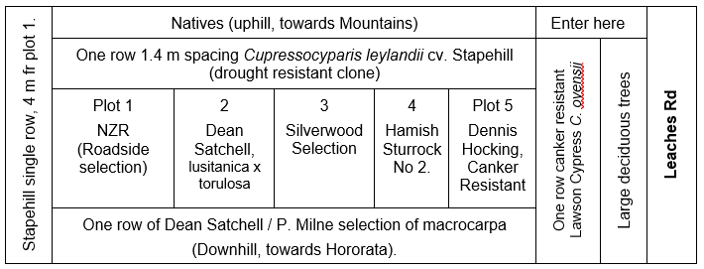

Average of three central trees in each plot, July 2021, following pruning to approx. 3 m: Pruned branches and DBH (cm).
Plot | 1  NZR | 2  DS | 3  SS | 4  HS No 2 | 5  DH
No of pruned branches, in 1 m of stem, starting above 1.7 m from ground | 15 | 22 | 13 | 16 | 25
DBH (cm) July 2021 | 16.4 | 17.6 | 18.7 | 17.3 | 21
Figure 1 Five plots of cypress lines, with guard rows on all four sides and the average number of pruned stubs and DBH for three trees in the centre of each plot (July 2021)

The Dennis Hocking plot – the first a visitor comes to (chosen for canker resistance) has the largest DBH and the most pruned stubs. It is a traditional macrocarpa – heavily branched but producing the most timber at twelve years old. By comparison, the Silverwood Selection is a good performer DBH wise at almost 19 cm, not far behind the Dennis Hocking selection, but with half the pruning effort. .

